

**JIMMA UNIVERSITY**

**JIMMA INSTITUTE OF TECHNOLOGY**

**DEPARTMENT OF WATER SUPPLY AND ENVIRONMENTAL ENGINEERING**

**CBTP PHASE I**

**DEMOGRAPHIC SURVEY AND PROBLEM IDENTIFICATION**

**A CASE: GINJO GUDRU KEBELE, JIMMA TOWN**

**SECTION I SUB-GROUP-3**

**ADVISORS:**

**1. SEIFU K.**

**2. BELKAN G.**

**Sub-mission Date: October 7, 2019**

**Jimma, Ethiopia**



**JIMMA UNIVERSITY**

**JIMMA INSTITUTE OF TECHNOLOGY**

**DEPARTMENT OF WATER SUPPLY AND ENVIRONMENTAL ENGINEERING**

**CBTP PHASE I**

**DEMOGRAPHIC SURVEY AND PROBLEM IDENTIFICATION**

**A CASE: GINJO GUDRU KEBELE, JIMMA TOWN**

**SECTION I SUB-GROUP-3**

No Group Members ID NO

1. GUTEMA ITICHA………………………………………RU3380/11-0

2. HAWI HAILE…………………………………………….RU4066/11-0

3. HAYMANOT TECHANE……………………………........RU3180/11-0

4 IBTISAM SEID……………………………………………RU4159/11-0

5 JUNED AWOL……………………………………………RU4291/11-0

6. KALID MAHAMED……………………………………...RU3657/11-0

7. KIDEST ASCHALEW…………………………………….RU3151/11-0

8. KIDUS ABREHAM……………………………………….RU4160/11-0

9. LELISA THOMAS…………………………………………RU3638/11-0

10. LEMMI MULETA………………………………………….RU3387/11-0

**Sub-mission Date: October 8, 2019**

**Jimma, Ethiopia**

**EXECUTIVE SUMMARY**

This demographic survey and problem identification (CBTP phase-I) is done in ginjo gudru kebele. The aim of CBTP phase-I is to identify the problem of the community by observing, distributing questionnaires and discussion through social demographic, language and cultural survey. Data had collected by providing questionnaires to randomly selected 30 houses as sample. The group have tried to identify the problems focusing on socio economic problem; demography, water supply, housing and waste disposal. As our questionnaires’ show we conducted the random sampling among the main problem facing the society such as:Housing, income and asset, main source of water supply, quality of water supply and environmental protection.As a water supply and environmental students we focused on the main water resourse and the quality of water the people using.

## ACKOWLEDGEMENT

First of all we would like to thank Jimma University and CBTP coordinator for providing us this useful opportunity that helps as to identify the community problems and figuring out problem solution methods. Secondly, we would like to appreciate our advisors Belkan G. and Seifu K. his advance and priceless support for this study till the end.Thirdly, we would like to thank the kebele leader and community of ginjo gudru for helping us as much as they can and to know better information about the community problems that they are dealing with.Lastly, we would like to express our deep expensive gratitude to the member of our group for their active and smooth participation in cooperating and collecting data in all activities of our study.

Contents

CHAPTER ONE 1

INTRODUCTION 1

1.1 BACKGROUND of cbtp 1

**1.2 BACKGROUND OF GINJO GUDUDRU……………………………………………………………………………………………..1**

1.3 OBJECTIVES 2

1.3.1 GENERAL OBJECTIVE 2

1.3.2 SPECIFIC OBJECTIVE 2

1.4 METHODOLOGY 2

1.4.1 DATA COLLECTION TECHNIQUE 2

1.4.2 METHOD OF DATA ANALAYSIS 2

1.5 SIGNIFICANCE OF THE STUDY 3

1.6 LIMITATION OF THE STUDY 3

1.6.1LIMITATION FROM STUDENT 3

1.6.2 LIMITATION FROM UNIVERSITY 3

1.6.3. LIMITATION OF THE COMMUNITY 4

CHAPTER TWO 5

HOUSE HOLED SOCIO-ECONOMIC AND DEMOGRAPHIC DATA 5

2.1 DEMOGRAPHIC COMPOSITION 5

2.1.1 AGE STATUS 5

2.1.2 SEX STATUS 6

2.1.3 RELIGION DISTRIBUTION 6

2.2 ETHINICITY 7

2.3 OCCUPATION STATUS 8

2.4 EDUCATIONAL STATUS 9

2.5 MARTIAL STATUS 10

2.6 INCOME AND ASSETS 10

2.6.1 ANNUAL FAMILY INCOME 10

CHAPTER THREE 12

WATER SUPPLY 12

3.1MAIN SOURCE OF WATER SUPPLY 12

3.1.1 WELL 13

3.2. WATER QUALITY 13

3.2.1 AMOUNT OF WATER UTILIZED 13

3.2.2 METHODS OF WATER STORAGE 13

3.3 DISPOSAL OF RIFUSE 14

3.4 UNPROPER WAY OF DISPOSAL OF SEWAGE 14

CHAPTER FOUR 15

4.1. ENVIRONMENTAL PROTECTION 15

*4.2 WAY OF ENVIRONMENTAL PROTECTION* 15

CHAPTER FIVE 16

CONCLUSION AND RECOMMENDATION 16

5.1 CONCLUSION 16

5.2 RECOMENDATION 17

REFERENCE ……………………………………………………………………………………………………………………………………………17

# CHAPTER ONE

# INTRODUCTION

Community based training program /CBTP/ is part of community based education (CBE) which is performed in different phases. In this program the first phase among the other is done by first year students. The overall purpose of CBTP is familiarizing the students with the society they are going to serve after graduation. In addition to that, it helps the students to create awareness about character of socio economic of the society. In the other way round, it paves the way for problem identification and getting solution as well for the problem which is the very important skill for students’ further work. In this program (CBTP) especially the kebele where the problem is identified will be threaten accordingly.

# 1.1 BACKGROUND OF CBTP

CBTP is established with Jimma University in 1983 as one of the strategies of community based education which is given in all departments in the University. This sustainable program runs up to graduation a long with an in built regular follow up program.

* 1. **BACKGROUND OF GINJO GUDRU**

Ginjo gudru kebele is one part of jimma city or this kebele is known kebele 5 consisting of kochi,katholic sefer,dipo,bakke moti, and aramic and this kebele is bounded by NORTH kebele 3( mendera kochi) ,SOUTH kebele 7(becho bore), EAST kebele 1 (awetu mendera), WEST kebele 5(ginjo gundru)

The main purpose of establishing this program is:

* To create awareness for students how to work with the society integrally?
* To teach the students how to solve the problem in serving the community.
* To encourage the community to forward their problems (CBTP).

## 1.3 OBJECTIVES

### 1.3.1 GENERAL OBJECTIVE

The general objective of CBTP phase I is to identify the problems of the community that related to water supply and sanitation.

### 1.3.2 SPECIFIC OBJECTIVE

* Identifying means of livelihood of the people.
* Determining the population distribution and basic social demographic characteristic like age, sex, religion, educational status, occupation status, marital status, and ethnicity.
* To strengthen the team spirit between the CBTP group students.
* To help the student get information how to collect, organize, analyze and interpret data.

## 1.4 METHODOLOGY

* After the orientation that was given by our coordinators, Then followed by certain methodologies that are essential for the completion of the program.

### 1.4.1 SOURCE OF DATA AND COLLECTION TECHNIQUE

Source of data collection can be divided into two categories secondary(desk study) which consists of stationary materials and field survey which consists of community of ginjo gudru and the kebele.

The data was collected using common stationary materials and techniques that are helpful for our project. Some of them are stationary materials like questionnaires and pens. We have used interviews, observation, capturing some photos of the actual problem that are observed in ginjo gudru and the map was used to indicate the location of kebeles.

### 1.4.2 METHOD OF DATA ANALAYSIS

* For this project 30 house were given as a sample. For each houses pair of students are assigned. The data is collected by distributing group members throughout the area. Three questionnaires per students are provided. From the overall collected data there have been able to know different kinds of problems that the society is facing specially problems related to our field of study.

## 1.5 SIGNIFICANCE OF THE STUDY

This CBTP program is available method of data collection from the community in order to identify the problems. The data collected is to be organized and analysis for future in policy making action plan drafting and a reference for development level of regions.

The organized and analyzed data give some information and recommendations regarding to the way for solving the problems of community.

## 1.6 LIMITATION OF THE STUDY

The sample study made the group members to face a lot of challenges nevertheless,it made us to observe a lot about the community but,the society were very frustrated because of the series disturbance of the students through asking same question and not finding any solution this leads to not giving information and also this sample study is insufficient because of the collection of some unreliable data.

### 1.6.1 LIMITATION FROM STUDENT

* Some students are unable to give attention to the program
* Few students are unable to use their time properly in the field

### 1.6.2 LIMITATION FROM UNIVERSITY

The university has its own limitation for this community based training program. Some of the limitations are:-

* Short period allocation for data collection.
* Unable to give brief and clear awareness to the student & communities.
* Repetition of data collection by different department at same kebeles.
* Unable to interact with the society practically.

### 1.6.3. LIMITATION OF THE COMMUNITY

* Many individuals can’t understand the aim and goal of this CBTP program because of lack of awareness. They conceive it as valueless.
* Unwillingness of some individuals to tell exact information.

# CHAPTER TWO

# HOUSE HOLED SOCIO-ECONOMIC AND DEMOGRAPHIC DATA

## 2.1 DEMOGRAPHIC COMPOSITION

### 2.1.1 AGE STATUS

According to our sample which is taken from 30 houses in gingo gudru kebele we categorize the age status of the sample community into four status .These are children, youth, adult and elderly people and detail classification was presented in table 2.1.

Table 2.1 Age status

|  |  |  |  |
| --- | --- | --- | --- |
| Age Group | Total number | | Percentage |
|  | Male | Female | Total |
| 0-15 | 15 | 10 | 26.31% |
| 16-30 | 14 | 17 | 32.63% |
| 31-50 | 16 | 15 | 32.63% |
| >50 | 4 | 4 | 8.43% |
| Total | 49 | 46 | 100 |

Figure 2.1 Age distribution

### 2.1.2 SEX STATUS

From the data that is collected from ginjo gudru the total number of Male & female is 49 & 46 respectively. This indicates that there is no big difference between sex status in the given sample area.

Table 2.2 Sex status

|  |  |  |
| --- | --- | --- |
| Sex | Total | % composition |
| Male | 49 | 51.57% |
| Female | 46 | 49.43% |

51.57%

49.43%

Chart 2.1 sex status percentage

### 2.1.3 RELIGION DISTRIBUTION

The collected information shows that from 98 peoples who lives in ginjo gudru kebele, 57.89% is Orthodox, 34.73%% is Muslim and finally 7.38% is protestant.

Table 2.3 Religion distribution

|  |  |  |
| --- | --- | --- |
| Religion | Total | Percent |
| Orthodox | 55 | 57.89% |
| Muslim | 33 | 34.73% |
| Protestant | 7 | 7.38% |

Chart 2.2 religion distribution percentages

## 2.2 ETHINICITY

When we collected this sample we observe that ginjo gudru is consisted of different ethinicity. This area has different variety of ethnic groups. Those ethnic groups are Oromo, Amhara, Gurage are consisted. The following table shows as the ethnic composition of ginjo gudru kebele.

Table 2.4 Ethnicity

|  |  |  |
| --- | --- | --- |
| Ethnic groups | Number of people | Percent |
| Oromo | 60 | 64.21% |
| Amhara | 17 | 18.95% |
| Gurage | 6 | 8.43% |

Chart 2.3 Ethnicity distribution percentages

## 2.3 OCCUPATION STATUS

The table below shows the different levels of occupation that the people in the community are carrying on, in order to support their life and their family. There are different categories like students, merchant, employed and housewife are listed.

|  |  |  |
| --- | --- | --- |
| Occupational status | Total number | % composition |
| Student | 26 | 42.10% |
| Employed | 32 | 20.00% |
| Housewife | 34 | 15.80% |
| Merchant | 28 | 22.10% |

Table2.5 Occupational status

20.00%

22.10%

15.80%

42.10%

Fig 2.2 Occupational status percentage

## 2.4 EDUCATIONAL STATUS

Education is the path from cocky ignorance to miserable uncertainty. Now a days most of our people are learned. The data obtained from ginjo gudru shows that many of them are educated in different levels.

Table 2.6 Educational status

|  |  |  |
| --- | --- | --- |
| Education Level | Total Number | % composition |
| Primary | 35 | 35.80% |
| Secondary | 27 | 29.47% |
| Higher | 28 | 28.42% |
| Illiterate | 12 | 6.31% |
| Total | 102 | 100 |

Chart 2.4 Educational level status

## 2.5 MARITAL STATUS

Through the collected data sample we are able to calculate the percentage composition of people that are married, single, widowed and divorced.

Table 2.7 Marital status

|  |  |  |
| --- | --- | --- |
| Marital Status | Total Number | % composition |
| Married | 48 | 49.48% |
| Single | 43 | 47.37% |
| Widowed | 2 | 3.15% |
| TOTAL | 93 | 100 |

## 2.6 INCOME AND ASSETS

## 2.6.1 ANNUAL FAMILY INCOME

During the investigation, there are different families income in ginjo gudro kebele, we found different directional incomes of those family such as business, Trade, salary and house rent, supported by family member. From this, most of the peoples’ income in the kebele based on salary and Business/trade/ labour. Now let us show the source in percent by using table

|  |  |  |
| --- | --- | --- |
| Annual Family Income | No of family | Percentage |
| Salary | 16 | 53.33% |
| Business/Trade/Labor | 14 | 40.01% |
| Rent | 6 | 6.66% |
| Total | 60 | 100% |

Table2.8 Annual Family income

Chart 2.5 Annual family incomes

# CHAPTER THREE

# WATER SUPPLY

**INTRODUCTION**

Water is one of the most important and basic thing for all living things to properly survive. It is obvious that water has a great role in house holding activities, to prepare food, to wash clothes and in general for the purpose of sanitation. The government avail water supply as much possible for the society but this availability is not in a good level.

## 3.1 MAIN SOURCE OF WATER DISTRIBUTION

There are different types of water supply source like pipe, yard tap, public stand, protected spring and unprotect spring but in our sample area the source of water supply is mostly pipe. The chart shown as follows:

Table 3.1 Main source of water supply

|  |  |  |
| --- | --- | --- |
| Water Supply | Number | %Composition |
| Pipe(inside house) | 17 | 50.00% |
| Pipe(Yard Tap) | 12 | 33.33% |
| Well | 1 | 16.67% |

16.67%

33.33%

50.00%

Fig 3.1 Main source of water supply

**3.1.1. WELL**

Our country Ethiopia is rich in underground water that we can get in a short depth. A few peoples of the ginjo gudru kebele uses well for washing their clothes and cleaning their houses. Well can be divided in to two, covered and uncovered. In our surveyed area almost all wells are covered.

## 3.2. WATER QUALITY

Water quality is described as the cleanliness, hardness, softness of the water. Water lost its quality by different cases like animals, society living around the water, by different wastes and mostly when it’s raining sometimes the water that comes from the pipe will be mudy which is not safe to drink. As we observe in ginjo gudru kebele the water quality is categorized under hard water. This mean the water have a good quality for the society.

### 3.2.1 AMOUNT OF WATER UTILIZED

Water is used for drinking, cleaning and for small scale plantation. Because of this in different house there is different amount of water utilized. Our collecting data shown as below

Table 4.1 Main source of water supply

|  |  |  |  |
| --- | --- | --- | --- |
| Amount of water in litter | No of families | % composition | |
| 0-30 | 12 | 36.67% | |
| 30-100 | 15 | 53.33% | |
| >100 | 2 | 10.00% | |
| Total | 29 | | 100 |

### 3.2.2 METHODS OF WATER STORAGE

There are different methods of water storage like bermel and jerrycan. In this kebele people uses those material for the purpose water storage where most people keep the cleanliness of the storage material well by washing the material and by other different methods.But when this stored water stays longer the quality of the water will decrease and its not safe to drink this indicates that we need to introduce some making water to stay clean longer as possible chemicals.

## 3.3 DISPOSAL OF RIFUSE

Disposing refuse is good way of removing waste material which is very important for our health. People dispose there refuse by different techniques like pit, open field, municipality service and other. According to our data most people dispose their refuse by pit and Municipality service. In this kebele the people don’t use refuse for the biogas purpose, but most of the time they used it as a fertilizer.

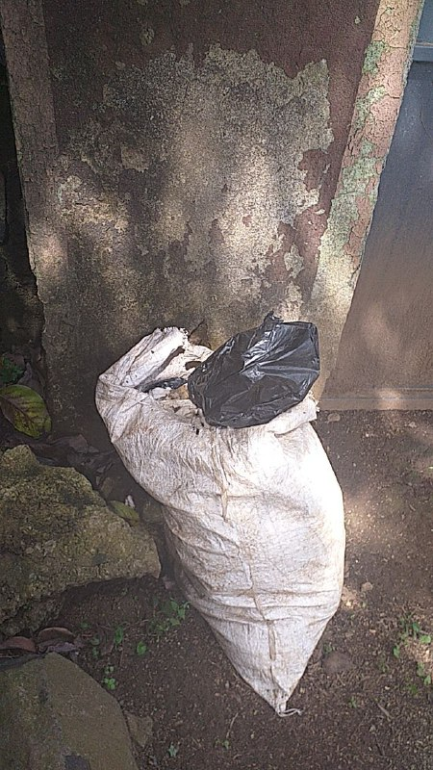

**3.4. UNPROPER WAY OF DISPOSING SEWAGE**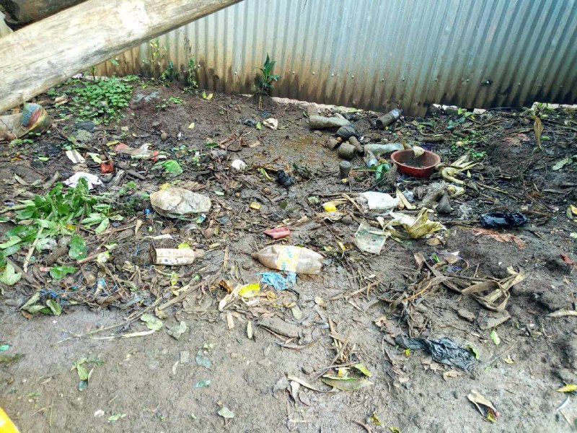

**CHAPTER FOUR**

**ENVIROMENTAL PROTECTION**

## 4.1 ENVIRONMENTAL PROTECTION

Environmental protection means keeping environment from different pollution. Environment is polluted by different factor for example when people dispose their refuse at different place randomly, by waste of industry and so on .This pollution can affect everyone’s health. To avoid this problem people protect their environment by cleaning the environment planting different trees

In this kebele there are many cause of pollution. These are:

* Not having many green areas or not planting trees around
* Plastic bottles and plastic bags all over the place
* improper disposal of trash

### 4.2 WAY OF ENVIRONMENTAL PROTECTION

As we observed in this kebele peoples use different method to protect their environment some of them are:-

* Using afforestation to reduce air pollution
* Burning wastes
* Using latrine to disposing waste material
* Cleaning the surrounding cooperatively

# CHAPTER FIVE

# CONCLUSION AND RECOMMENDATION

## 5.1 CONCLUSION

As we mentioned before ginjo gudru is consisted of different nation and nationalities with in different age group, sex, Religion, level of education, Occupational status and marital status. In case of age group the youths (14-30 ages) occupies the largest number of the community.

The community has different source of annual family income such as monthly salary, business, and house rent. As we observed most of the societies are employed and house wifes. That means they do not have their own income and they are dependent in their families.

In the side of information Medias, it can be concluded that most people are users of telephone (either fixed telephone or mobile phones) and many of the community people use TV/radio.

From the survey we come up with the following conclusions;

* Depending up on our field trip most of the families don’t own land and they don’t own vehicles
* The income of most families depends up on rent and employment.
* majority of the people do not have computer access( no internet cafes)
* In this kebele,people are struggling in getting clean and healthy water even enough water is not provided.

## 5.2 RECOMENDATION

Depending, CBTP problem identification phase I, we have to give recommendations for the problems that we observed at that time were:

* Concerned body should give awareness for the society regarding this education.
* Recreational area like youth center, internet café,library, park and etc should be provided for the community.
* Also, public stand water for this community is required.

REFRENCE

Gingo Gudru administrative office

* *The socity of gingo gudru*

MAP OF GINJO GUDURU KEBELE

